13. Aura to LWC Communication, LWC to Aura Communication using LMS- 20 Sep 2021

Today we will learn:

1] Aura to LWC Communication Using LMS

2] LWC to Aura Communication Using LMS

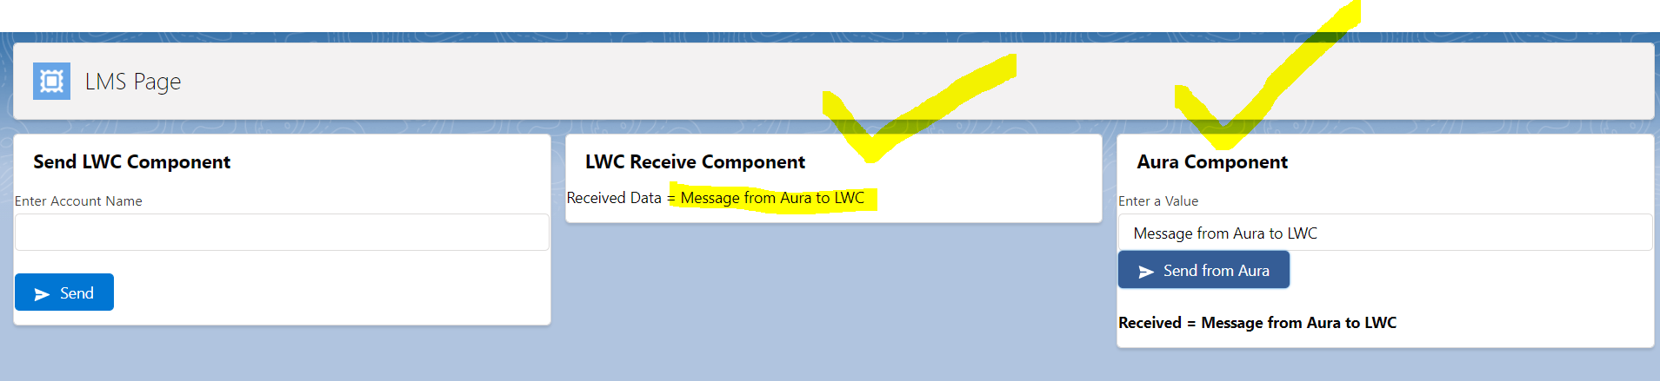

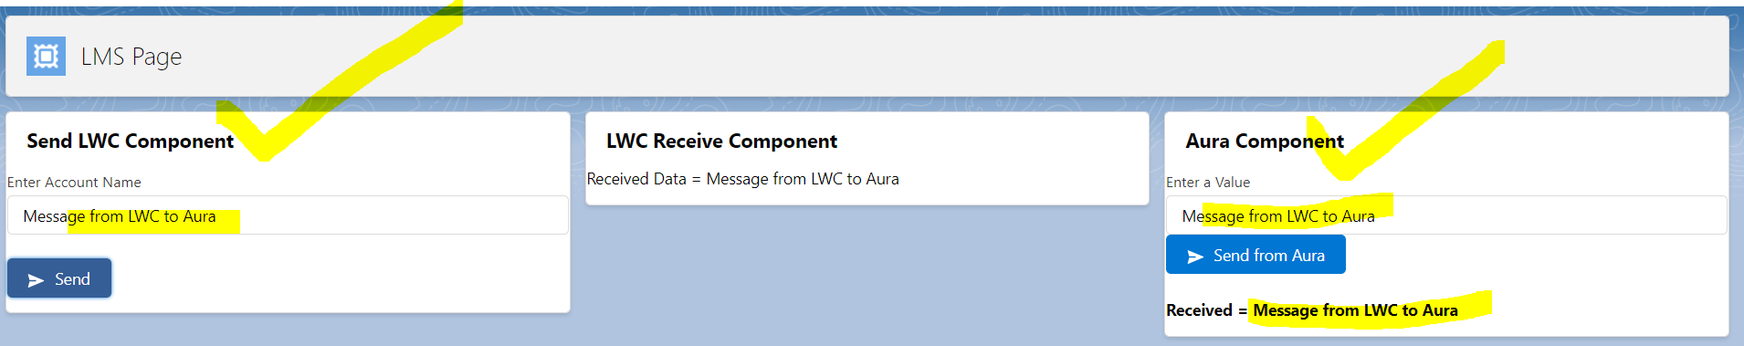

1] Aura to LWC Communication

**Lightning Message Service**

messageChannel

accData

**LWC Component**

Received Data = CINEMAX

**Aura Component**

CINEMAX

<lightning:messageChannel

aura:id="msgChannelID"

type="AccountDataChannel__c"

scope="APPLICATION"

/>

sendDataHandler : function(component, message){

component.find("msgChannelID").publish(message);

}

Button

2] LWC to Aura Communication

**Lightning Message Service**

messageChannel

accData

**LWC Component**

Value = CINEMAX

**Aura Component**

Received Data : CINEMAX

<lightning:messageChannel

aura:id="msgChannelID"

type="AccountDataChannel__c"

scope="APPLICATION"

onMessage=”{!c.handleLWCMessage}”

/>

handleLWCData : function(component, message){

if(message!=null && message.getParam("accData")!=null){

component.set("v.myAuraData",message.getParam("accData").value);

}

}

<aura:component implements="flexipage:availableForAllPageTypes" access="global">

    <aura:attribute name="myMessage" type="String" />

    <lightning:messageChannel

        aura:id="msgChannelID"

        type="AccountDataChannel__c"

        scope="APPLICATION"

        onMessage="{!c.receiveDataHandler}"

    />

    <lightning:card  title="Aura Component">

        <lightning:input type="text" name="input1" label="Enter a Message" value="{!v.myMessage}"/> <br />

        <lightning:button variant="brand" label="Send From Aura"  iconName="utility:send" title="Brand action" onclick="{!c.sendDataHandler}" />

   <br /><br />

   Received From LWC = {!v.myMessage}

    </lightning:card>

</aura:component>

({

    sendDataHandler : function(component, event, helper) {

        var myMessage = component.get("v.myMessage");

        const message = {

            accData:{

                value:myMessage

            }

        }

        component.find("msgChannelID").publish(message);

    },

    receiveDataHandler : function(component,message){

            component.set("v.myMessage", message.getParam("accData").value)

    }

})